Part Number: PT922-03181
PT922-03182

Kit Contents
Item # | Quantity Reqd. | Description
1 | 1 | Door sill, Front Right Hand
2 | 1 | Door sill, Front Left Hand
3 | 1 | Door sill, Rear Right Hand
4 | 1 | Door sill, Rear Left Hand
Hardware Bag Contents
Item # | Quantity Reqd. | Description
1
2
3
Additional Items Required For Installation
Item # | Quantity Reqd. | Description
1
2
Conflicts
Illuminated Door Sill
Recommended Tools
Personal & Vehicle Protection | Notes
Safety Glasses
Safety Gloves | Optional
Blankets, Part Boxes
Special Tools | Notes
Nylon Panel Removal Tool
Painter’s Tape | If necessary
Installation Tools | Notes
Special Chemicals | Notes
Cleaner | VDC approved cleaner
General Applicability
Gas and Hybrid models
Recommended Sequence of Application
Item # | Accessory
1 | Security
2 | Remote Engine Start
3 | Door Sill Protector
*Mandatory
Vehicle Service Parts (may be required for reassembly)
Item # | Quantity Reqd. | Description
1
2
3
Legend
STOP: Damage to the vehicle may occur. Do not proceed until process has been complied with.
OPERATOR SAFETY: Use caution to avoid risk of injury.
CAUTION: A process that must be carefully observed in order to reduce the risk of damage to the accessory/vehicle and to ensure a quality installation.
TOOLS & EQUIPMENT: Used in Figures calls out the specific tools and equipment recommended for this process.
REVISION MARK: This mark highlights a change in installation with respect to previous issue.
SAFETY TORQUE: This mark indicates that torque is related to safety.

Care must be taken when installing this accessory to ensure damage does not occur to the vehicle. The installation of this accessory should follow approved guidelines to ensure a quality installation.

These guidelines can be found in the "Accessory Installation Practices" document.

This document covers such items as:-
- Vehicle Protection (use of covers and blankets, cleaning chemicals, etc.).
- Safety (eye protection, rechecking torque procedure, etc.).
- Vehicle Disassembly/Reassembly (panel removal, part storage, etc.).
- Electrical Component Disassembly/Reassembly (battery disconnection, connector removal, etc.).

Please see your Toyota dealer for a copy of this document.

Prepare for the Installation.
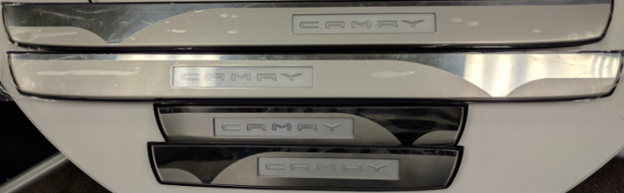
  - Check the kit for missing parts or any damage (Fig. 1-1).
Fig. 1-1
  - Check the following for damage:
    - One (1) front LH door sill
    - One (1) front RH door sill
    - One (1) rear LH door sill
    - One (1) rear RH door sill

Disassemble the Vehicle.
NOTE: Unless otherwise specified, the procedure for driver and passenger side is the same.
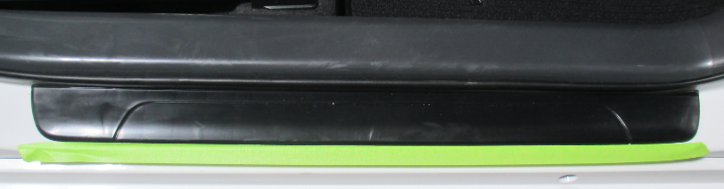
  - Apply painter’s tape to the length of the rocker panel against the front OE door scuff to protect the vehicle body paint (Fig. 2-1).
Fig. 2-1

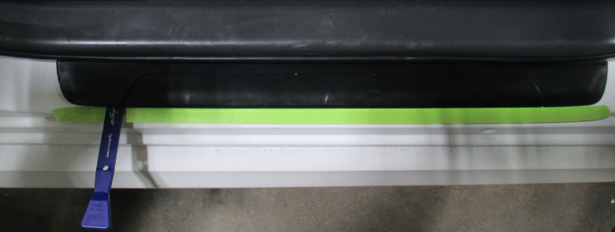
  - Use a nylon panel removal tool to disengage the four clips and remove the front left and front right outer door scuff plates (Fig. 2-2).
Nylon panel removal tool
Clips
Fig. 2-2

NOTE: Use caution while removing the door scuff to not break any of the molded clips.

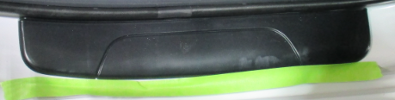
  - Apply painter’s tape to the length of the rocker panel against the rear OE door scuff to protect the vehicle body paint (Fig. 2-3).
Fig. 2-3

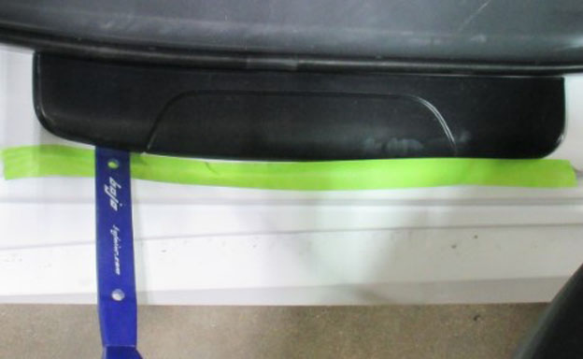
  - Use a nylon panel removal tool to disengage the two clips and remove the rear left and rear right outer door scuff plates (Fig. 2-4).
Clips
Fig. 2-4
Nylon panel removal tool

NOTE: Use caution while removing the door scuff to not break any of the molded clips.

Install the Front Door Scuff Plates.
NOTE: Unless otherwise specified, the procedure for the driver and passenger side is the same.
  - Locate the front left hand (LH) door scuff plate.
    - “LH” is indicated on the back of the door scuff plate.
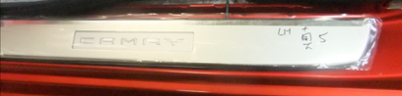
    - When installing the door sill on the correct side, the word “CAMRY” should be readable from the outside of the vehicle (Fig. 3-1)
Fig. 3-1
Front of vehicle
  - Align the 4 clips of the door scuff plate to the holes of the body rocker panel. Gently push the door scuff plate down to insert the clips starting with the 3rd clip from the front (Fig. 3-2).
Fig. 3-2
1st

NOTE: Make sure the door scuff plate is properly snapped down in place with no lifting or uneven gaps around the edges. A snap should be heard as each clip engages into the rocker.

Install the Rear Door Scuff Plates.
NOTE: Unless otherwise specified, the procedure for the driver side and the passenger side is the same.
  - Locate the rear right hand (RH) door scuff plate and the rear left hand (LH) door scuff plate.
    - The right hand door scuff plate is for the passenger side and the left hand door scuff plate is for the driver side.
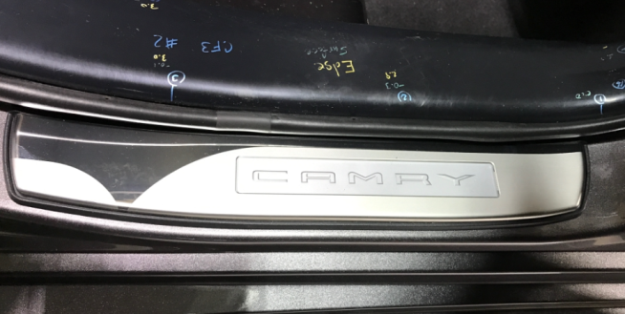
    - When installing the door sill on the correct side, the word “CAMRY” is toward the front of the vehicle (Fig. 4-1)
Fig. 4-1
Front of vehicle

NOTE: “RH” and “LH” is indicated on the back of the door scuff plate.

  - Line up the 2 clips with the mounting holes in the body. Gently push the door scuff plate down to insert the clips (Fig. 4-2).
1st
Fig. 4-2
    - Ensure the clip that is denoted as 1st on Fig 4-2 is aligned and clipped into the rocker panel prior to engaging the second clip.
Clips
    - Make sure the door scuff plate is properly snapped down in place with no lifting or uneven gaps around the edges.

Complete the Installation.
  - Perform any accessory or vehicle function checks.
  - Clean up and remove any trash.

Accessory Function Checks
Door sill fitment

Open the doors

Vehicle Function Checks
None

Vehicle Appearance Check
After accessory installation and removal of protective cover(s), perform a visual inspection.

There should be no uneven gaps around the edges, and clips should be securely fastened.
Door sill should not interfere with the door.

Ensure no damage (including scuffs and scratches) was caused during the installation process.
(For PPO installations, refer to TMS Accessory Quality Shipping Standard).

